Waltron and LTH Electronics Join Forces in Water Quality Analysis

- The collaboration will deliver new end-to-end solutions for operators managing steam and water analysis systems in various industrial applications.
- The initial focus will be on launching the Waltron 4000-Series, with the first shipments of these all-new LDO, pH, and Conductivity instruments beginning in 4Q2023
- Complementary solutions will allow customers options for further parameters and innovative multi-channel control systems.

November 21, 2023

FLEMINGTON, NEW JERSEY -- Waltron Bull & Roberts, LLC, and LTH Electronics, Ltd. have announced their strategic partnership in high-performance water quality instrumentation and sensors. With an initial product launch of the most popular parameters of Dissolved Oxygen, pH, and Conductivity, the companies will jointly offer a broader range of solutions to help analytical customers efficiently manage their facilities’ steam and water quality. For LTH and Waltron, this deeper relationship strengthens both organizations' efforts to expand their water chemistry solutions.

Experience suggests that the vast majority of today's industrial operations will still be standing thirty years from now – which means the challenge of controlling water chemistry, particularly in older sites, will only become more acute over the coming decades. Many facilities lack the on-site expertise and personnel to monitor and optimize water quality and usage, making maintenance tasks more expensive and laborious. Waltron and LTH offer unique and complementary services to address these shortfalls and will work with customers to map a path toward improving long-term plant resilience.

LTH Electronics, Ltd. (www.lth.co.uk) brings a deep background in creating intelligent liquid measurement systems for applications that require accurate and reliable process control and measurement. LTH is best known for its continuous investment in research and development, with 50 years of experience manufacturing high-tech instrumentation and sensors for many industrial applications.

"The strength of LTH Electronics is our ability to offer the best service and solutions to solve customers’ most challenging process problems," said Neil Adams, Managing Director of LTH Electronics, Ltd. "By teaming up with a global leader like Waltron, we can take that insight and provide an end-to-end solution from planning to execution and ongoing maintenance that allows our combined customers demonstrate the value of their investment to plant and corporate management."

Waltron Bull & Roberts, LLC (www.waltron.net) recently celebrated its 120th anniversary, marking a long history of steam and water chemistry management expertise. Best known for building a broad range of highly accurate instruments for ultra-pure water, the company offers product and service solutions that help industrial facilities maintain their peak efficiency. It also manufactures high-quality reagents and standards shipped worldwide for Waltron and other branded analyzers. Its innovations in degassing technology and management of film-forming chemistry have earned it a devoted following among big-name customers around the globe.
Waltron’s President and CEO, Jon Guy, explained, "I am very excited by our deepening collaboration with such a highly-regarded company as LTH Electronics. They bring tremendous capabilities into the partnership, and both companies extend their reach into new markets and industry segments. Whether practically through releasing our all-new 4000-Series pH and Conductivity range of analyzers or strategically blending our diverse skills and experience, this can only bring significant long-term benefits to our combined customers."

The following steps for the new partnership include releasing new solutions to address further analytical parameters and innovative multi-channel control systems.

Image: https://waltron.net/wp-content/uploads/2023/10/4000-Series-Transmitter-1024x1024.png
More information: https://waltron.net/4000-series-ph-conductivity-analyzer/

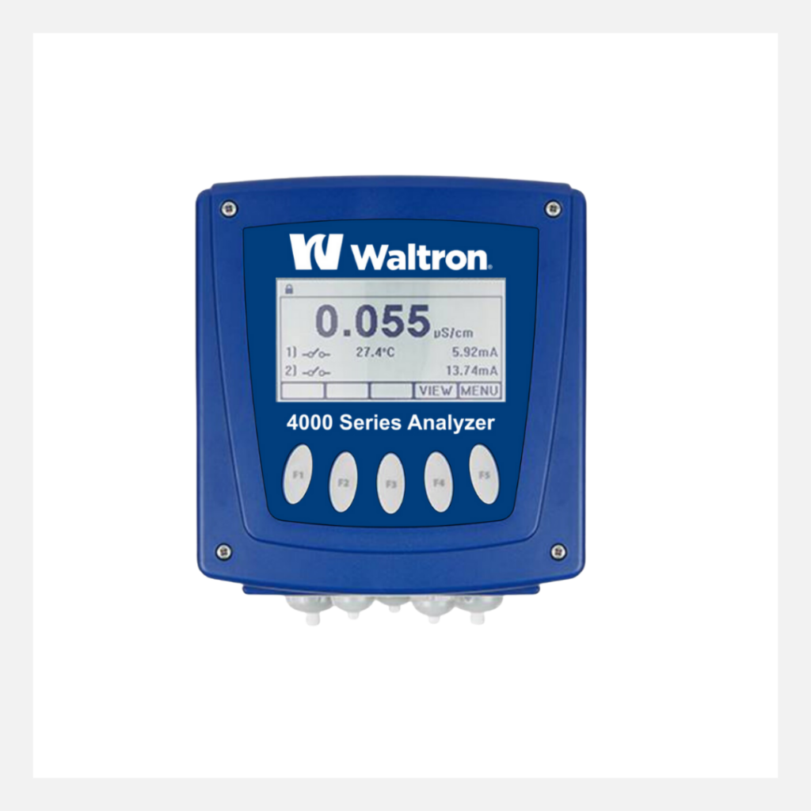

###

_________

FOR MORE INFORMATION
Kate Gallagher | K8 Digital
Waltron Bull & Roberts, LLC
615-830-2287 | Kate@K8Digital.com

